**INTRODUCTION**

The main purpose using computerized system is to avoid manual problems and also documentation storage problem we can’t maintain long period data that’s why we used computerized system to overcome all problem related to college data storing and other areas.

**College Management System** is a desktop based system that maintains all the activity related to College Admission Process. This project works on Microsoft Access Database in which the data will be imported for Excel file. All the operation will be performed on the data provided in the excel file. The data will first be imported from the excel file into access data base after that the data imported in access will be operated according to the requirement.

Data inside excel file will be the data of those students, who have registered online for the entrance exam of the college.

After operating the data, reports will be generated (i.e. list of registered student, list of admitted student, list of students according to their category).

Because of manual system we faced many problems. The maintenance cost of manual system was very high. And they didn’t store historical information and not possible to view all at a time.

**OBJECTIVE**

College Management System is a desktop based System that is designed to maintain all the activity related to admission process of a college, it stores all the information of registered student and operate the data to complete the task desired by the user such as:-

1. Maintaining the marks obtained by the student in entrance exam.
2. Generating rank list according to the obtained marks.
3. Update student record.
4. Delete student record.
5. Generate reports according to the category of the student.

Objective:-

* To calculate rank according to the obtained marks of the student.
* To convert the manual work to system based.
* To maintain the information of student in a single System. To remove data redundancy.
* To provide security to the data, as a single person has the authority to access the data or to manipulate the data.

**PLATEFORM SPECIFICATION**

**Hardware Minimum Requirements**

1GHz + CPU

103MB RAM

**Software Requirement**

Operating System – Windows 10

Back end – MS Access

Front end – Visual Basic.Net

Microsoft Visual Basic 2010

**ER- Model**

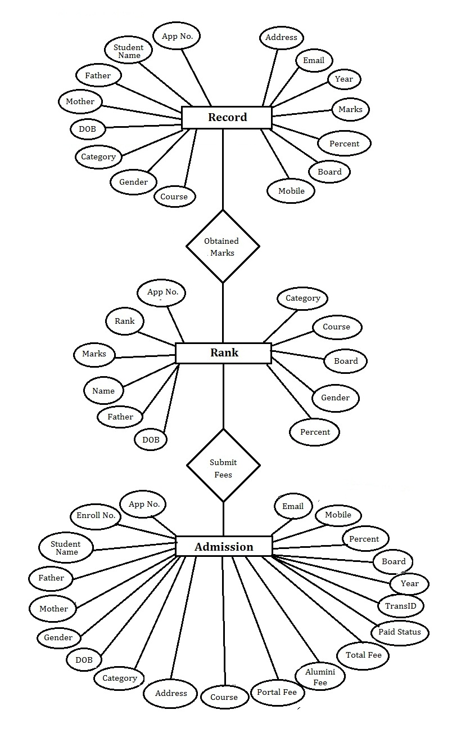

Figure - 1

**DATA FLOW DIAGRAM (DFD)**

**Zero Level**

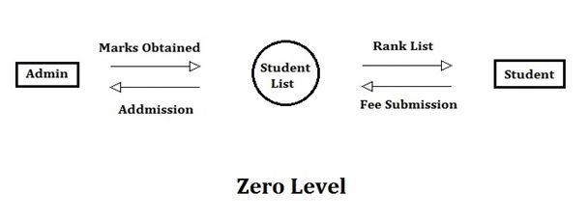

**First Level**

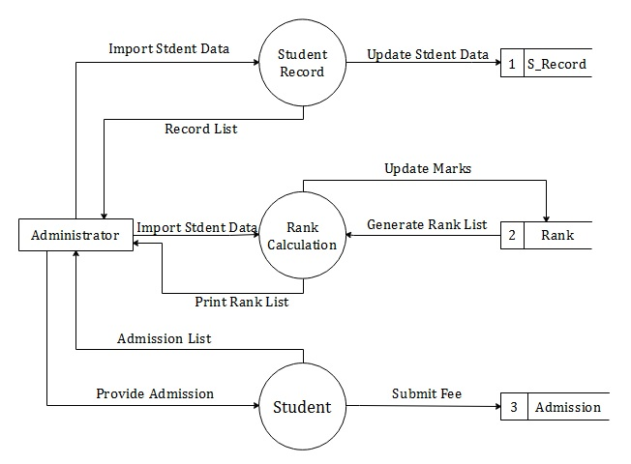

**Figure-2**

Figure - 2

**SYSTEM DESIGN**

**System design** is the process of defining the modules, interfaces, and data for a system to satisfy specified requirements.

**Logical design**

The logical design of a system pertains to an abstract representation of the data flows, inputs and outputs of the system. This is often conducted via modelling, using a graphical model of the actual system. Logical design includes entity-relationship diagrams (ER diagrams) and data flow diagram (DFD).

**Physical design**

The physical design relates to the actual input and output processes of the system. This is explained in terms of how data is input into a system, how it is processed, and how it is displayed.

The physical portion of system design can generally be broken down into three sub-tasks:

1. **User Interface Design**

*“User Interface Design is concerned with how users add information to the system and with how the system presents information back to them.”*

In College Management System, there are multiple interfaces provided to add information to the system and to present information back to the user.

Interfaces to add information to the system are as follows:-

1. **Import student record:-**

These interface is provided to import the registered student in grid view from excel and add data into System’s data storage space.

1. **Update Registered Student:-**

These interface is provided to update the previously imported information of registered student, if required.

1. **Enter Entrance Marks:-**

These interface is provided to add the marks (obtained by the student in entrance examination) to information which was imported previously.

1. **Fee Data Import:-**

These interface is provided to add the information of those student, who have submitted the fee, to get the admission.

1. **Update Student:-**

These interface is provided to update the information of admitted students.

1. **Import Enrollment Data:-**

These interface is provided to import the generated enrollment number regarding each student, who have got the admission and is promoted to the desired course.

1. **Delete Admitted Student:-**

These interface is provided to delete the information of the student from the system’s storage space, who have left the course after taking the admission.

Interfaces to provide the information to the user are as follows:-

1. **Rank Calculation:-**

These interface is provided to display the calculated rank of the student, according to the marks obtained in the entrance examination.

1. **Search Registered Student:-**

These interface is provided to display the information of any single student at a time, whose application number must be inserted by the user.

1. **List Registered Student :-**

These interface is provided display all the information of those student who have registered for the examination.

1. **Rank List:-**

These interface is provided to display the rank list of students calculated on the basis of obtained marks in entrance examination.

1. **Admitted Student List:-**

These interface is provided to display the list of admitted student.

**2. Data Design**

Data Design is concerned with how the data is represented and stored within the system.

In College Management System, data is represented in the same format as it was retrieved in excel sheet from the website, where the students have registered for the entrance examination.

The data from excel sheet will be imported and will be stored in access data base, in the form of tables. Data or information of student imported in database will be stored in the table named as “Record”.

**3. Process Design**

Process Design is concerned with how data moves through the system, and how it is transformed as it flows into, through and out of the system.

In College Management System, as the data was retrieved in excel and was imported in the table (Record) of access database. These table Record is having an attribute as “Marks”, which will have its initial value as zero. The value of Marks will be added to the table using a user interface.

As the marks of the student are inserted in the table, the rank list of the students will be generated in Rank table. According to which admission will be provided to eligible student, who have submitted the fee. Data of admitted Student will stored in different table named as Admission.

**SYSTEM IMPLEMENTATION**

Implementation is the stage of the project where the theoretical design is turned into a working system.

The above system design will now be physically implemented. Steps of implementation of College Management System:-

* 1. Student record will be retrieved from the website in excel sheet.
  2. An interface will be provided to import the data of excel sheet into access database table (Record).
  3. Details of registered student can be updated through the update student form which will provide access to the user to update the details of registered student for entrance exams such as name, father’s name etc.
  4. Entrance marks can be entered in two ways either it can be imported through the excel sheet or it can be directly entered through grid view.
  5. Rank list generated on the basis of marks obtained and the list is stored in the table named Rank.
  6. Multiple Rank list can be generated like common rank list or can be generated category wise like OBC candidates, SC & ST candidates.
  7. Admission will be provided if the student is eligible and have submitted the fee, the fee record of student again imported from the excel sheet.

**UNIT TESTING**

1. **Login Form:-**

The username and password are case sensitive.

1. **Import student record:-**

Records in the excel sheet must have exact same number of columns as record table.

1. **Update Registered Student:-**

Valid application number should be inserted by the user to search the student. Contact must be of 10 digits

1. **Enter Entrance Marks:-**

The marks entered corresponding to an application number is storing to exact application number in data base

1. **Fee Data Import:-**

The data stored in the excel sheet is imported to access database corresponding to the application number and the student record is transfer to the Admission table.

1. **Update Student:-**

Authentication of records that can be updated is provided to the user.

1. **Import Enrollment Data:-**

Enrollment number is imported from the excel sheet and stored to the corresponding application number.

1. **Delete Admitted Student:-**

The record is deleted from access database of the student whose record is searched from his/her name or application number.

1. **Rank Calculation:-**

Rank is calculated from the marks and record is inserted into the rank table.

1. **Search Registered Student:-**

Student record is searched from the application number.

1. **List Registered Student :-**

These interface is provided display all the information of those student who have registered for the examination.

1. **Rank List:-**

These interface is provided to display the rank list of students calculated on the basis of obtained marks in entrance examination.

1. **Admitted Student List:-**

These interface is provided to display the list of admitted student.

**OUTPUT FORMS AND REPORTS**

**Login form**

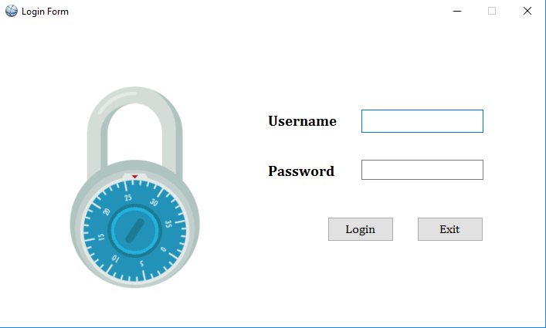

**Figure-3**

**Dashboard** **form**

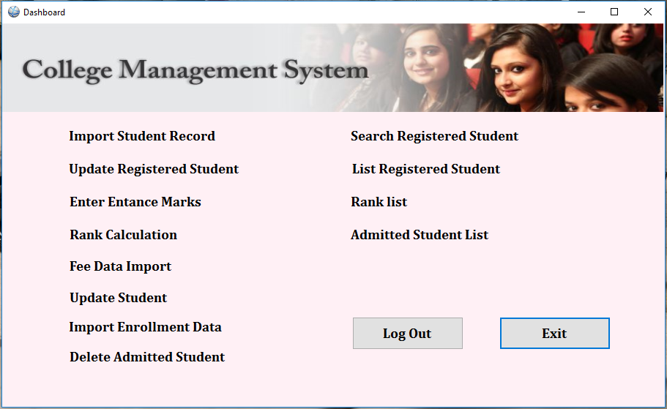

**Figure-4**

**Import Student Record**

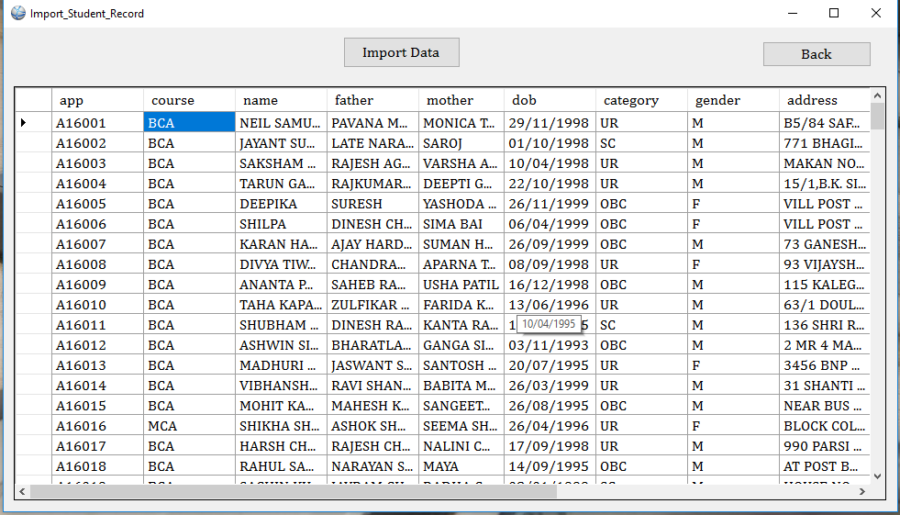

**Figure-5**

**Update Student Record**

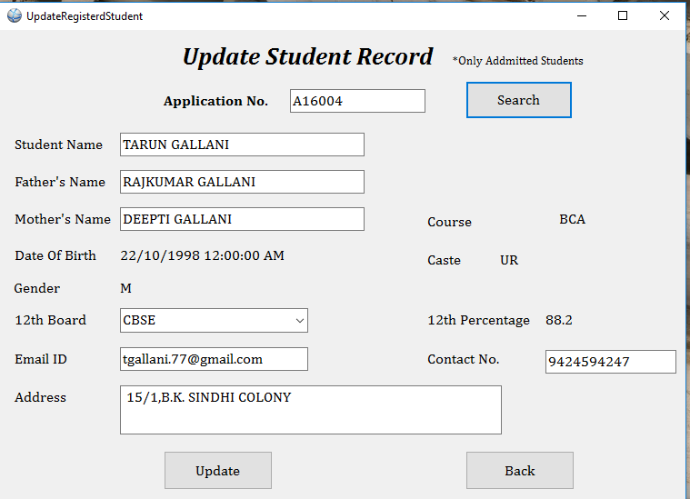

**Figure-6**

**Enter Entrance Marks**

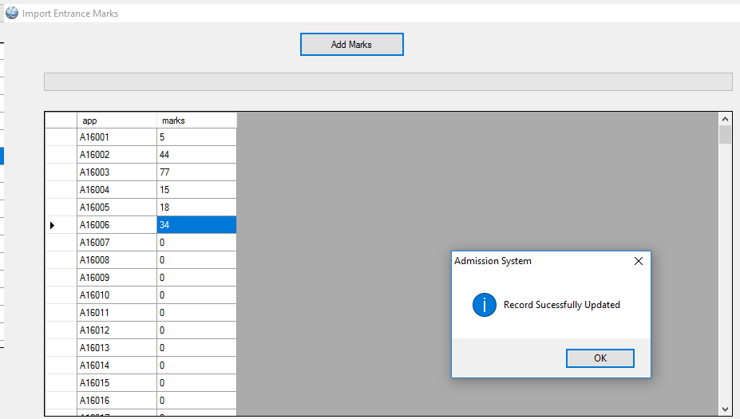

**Figure-7**

**Rank Calculation**

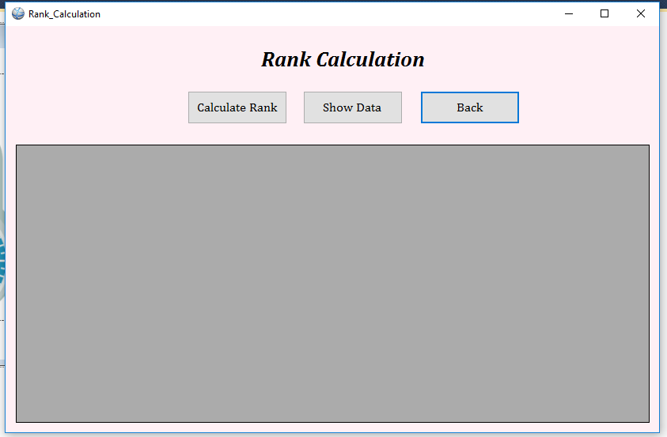

**Figure-8**

**Update Student**

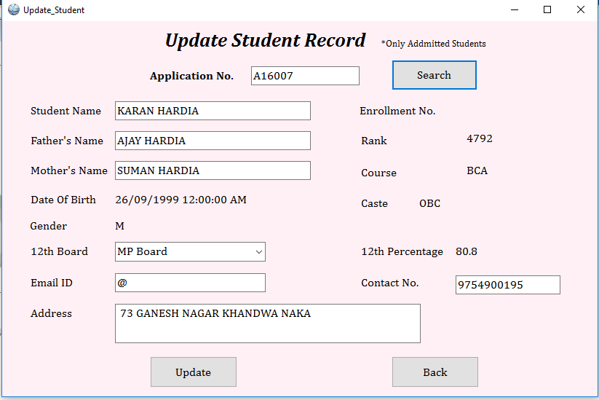

**Figure-9**

**Import Enrollment Data**

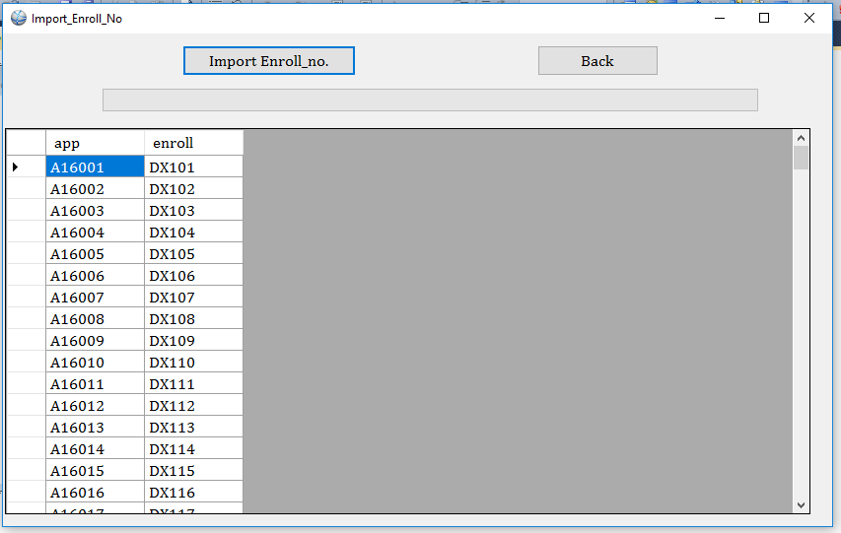

**Figure-10**

**Delete Admitted Student**

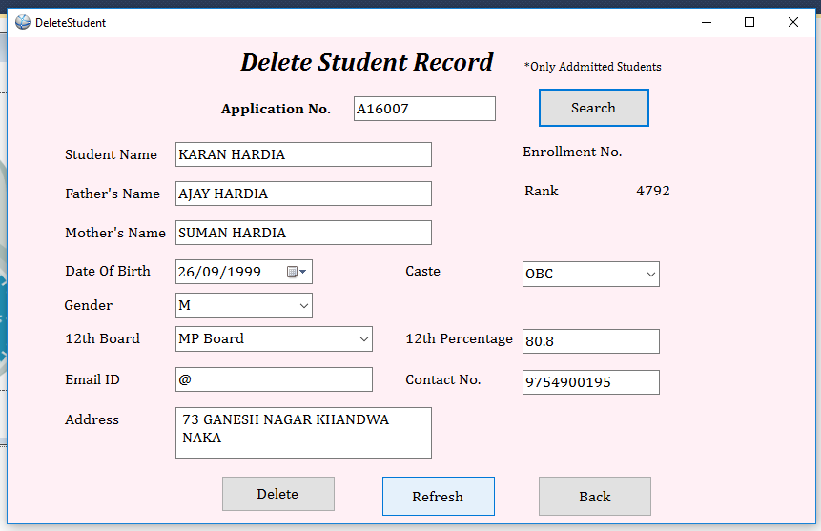

**Figure-11**

**Search Registered Student**

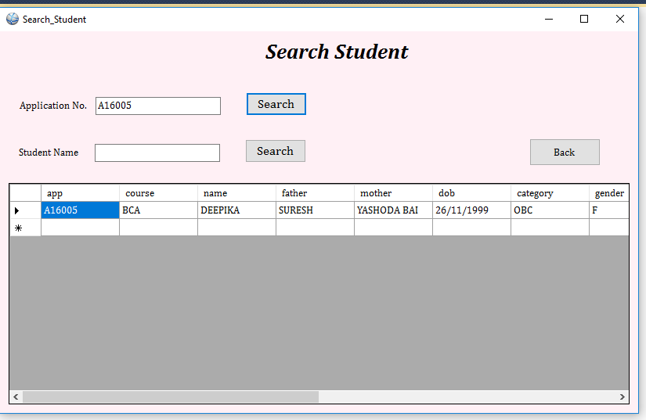

**Figure-12**

**List of Registered Student**

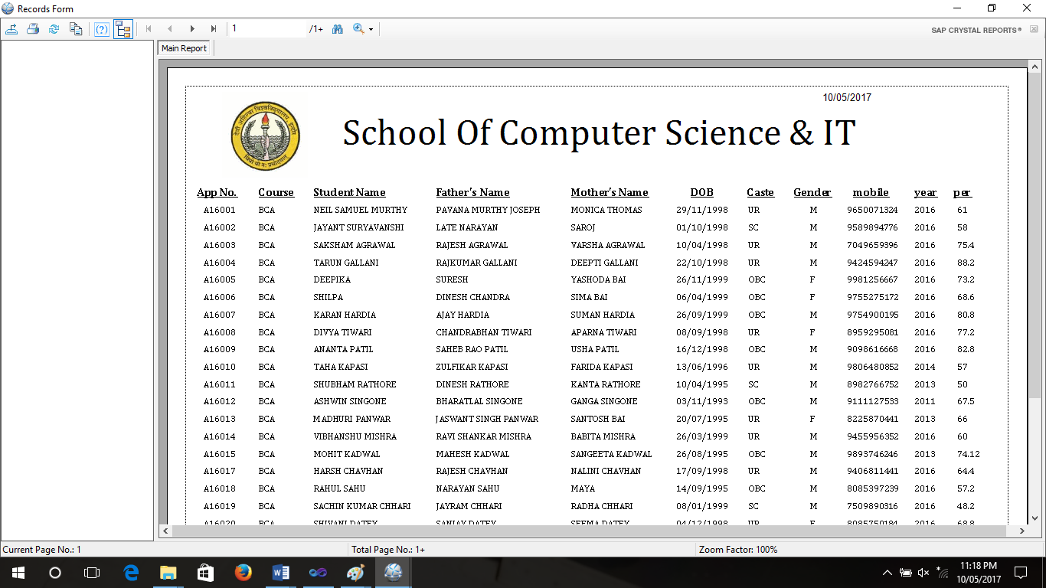

**Figure-13**

**Rank List**

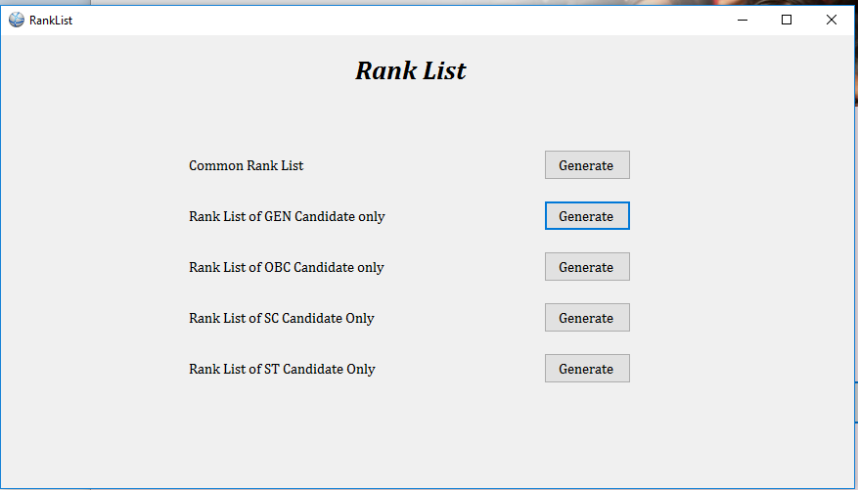

**Figure-14**

**Common Rank** **List**

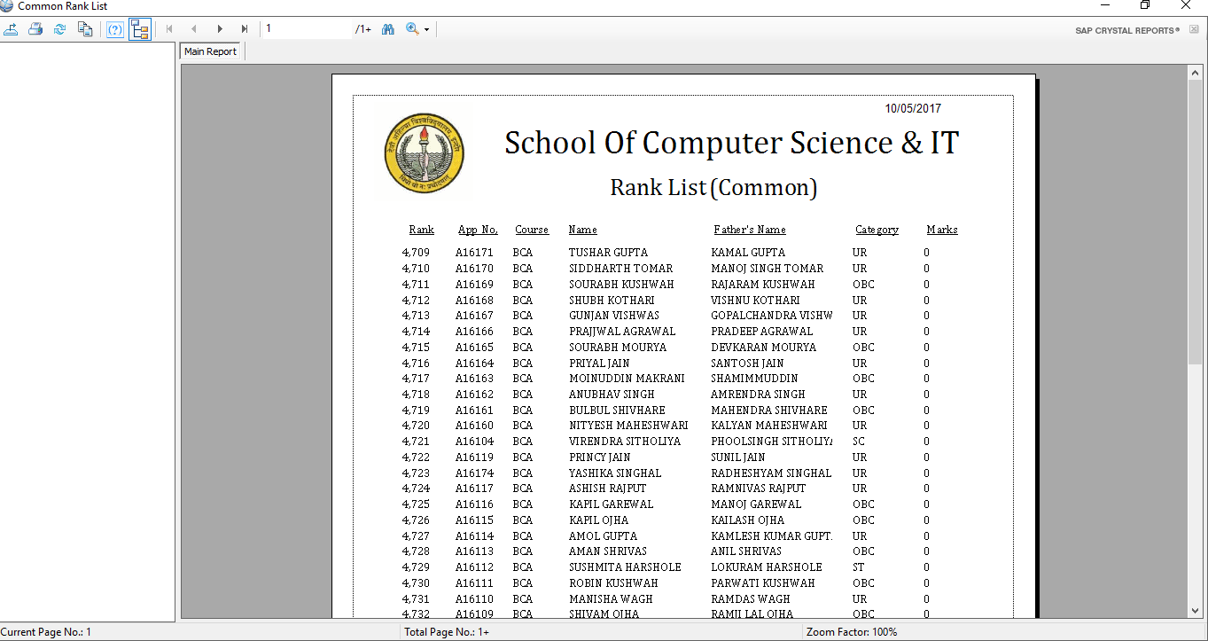

**Figure-15**

**Rank List (General Candidates)**

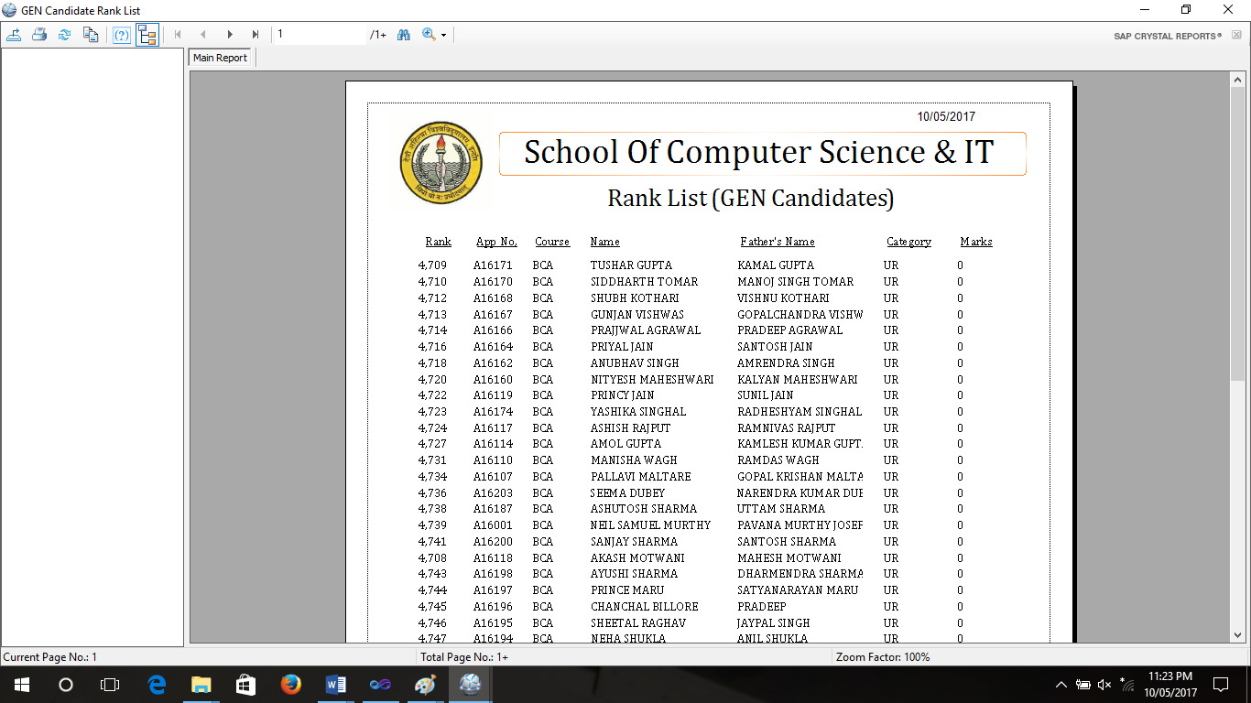

**Figure-16**

**Admitted Student List**

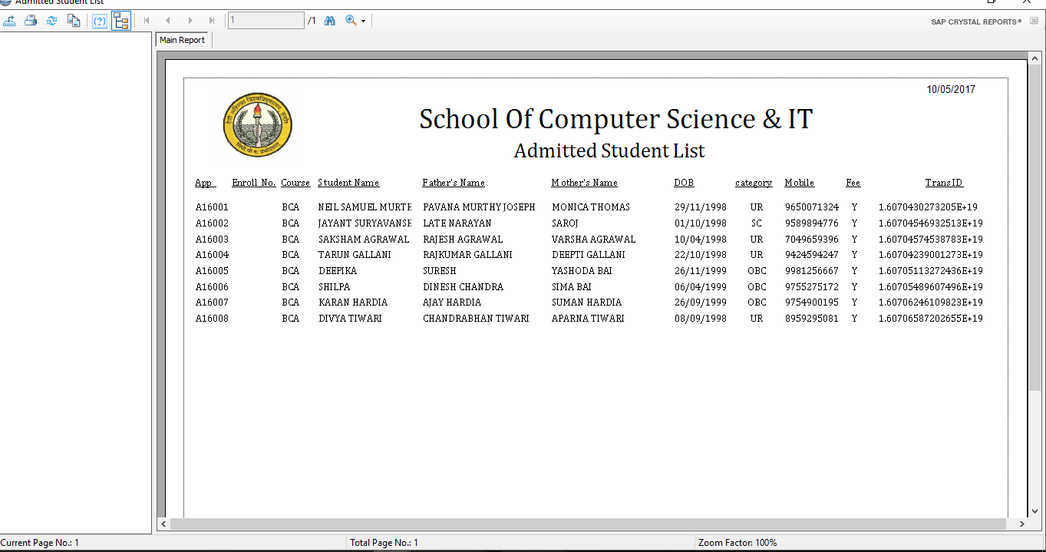

**Figure-17**

***Database***

Admission Table

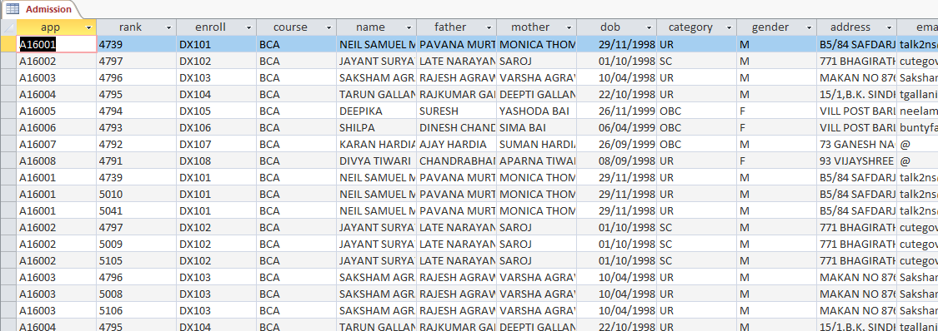

**Figure-18**

Rank Table

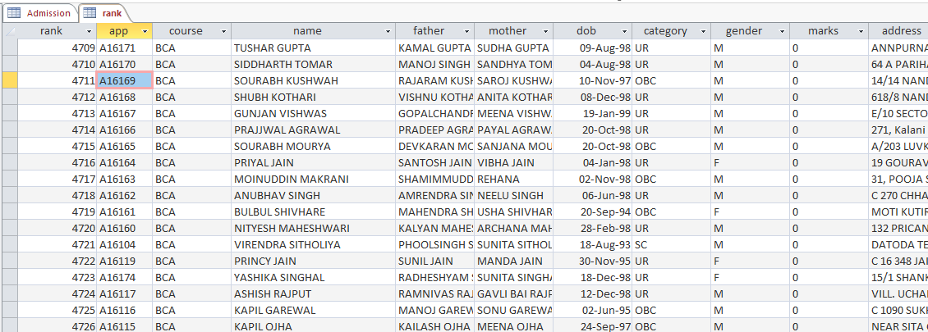

**Figure-19**

Record Table

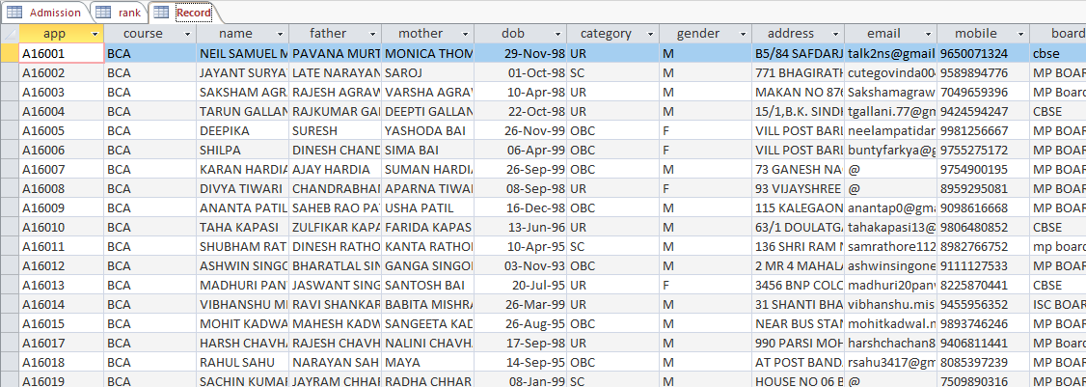

**Figure-20**

***Excel Sheets***

Registered Student list

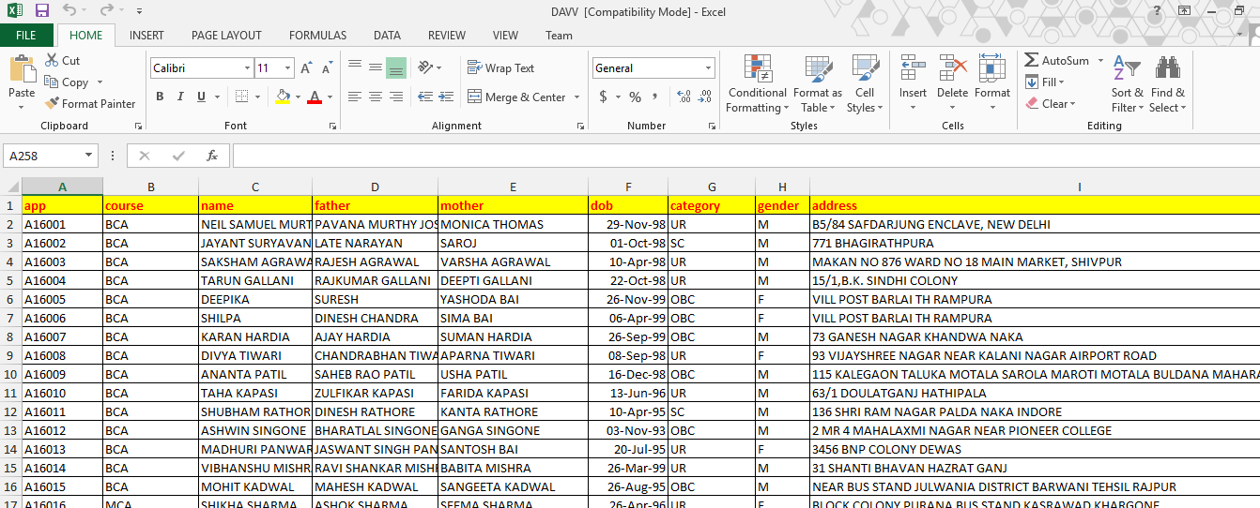

**Figure-21**

Marks List

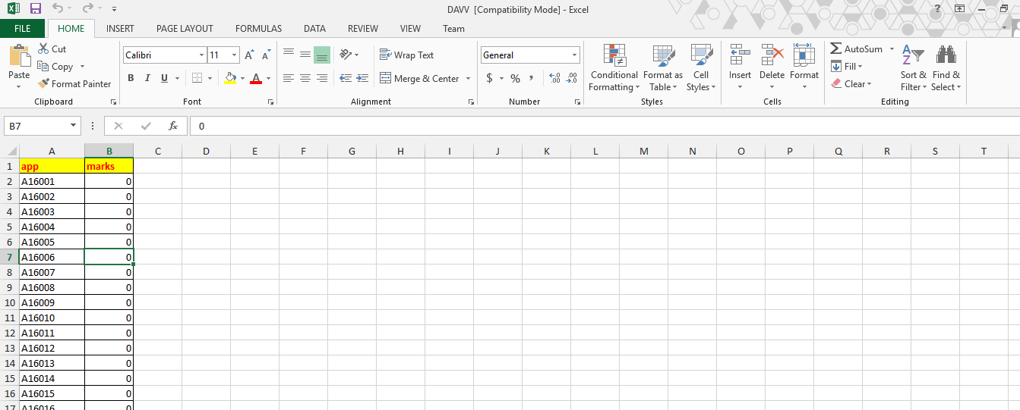

**Figure-22**

Fee Record

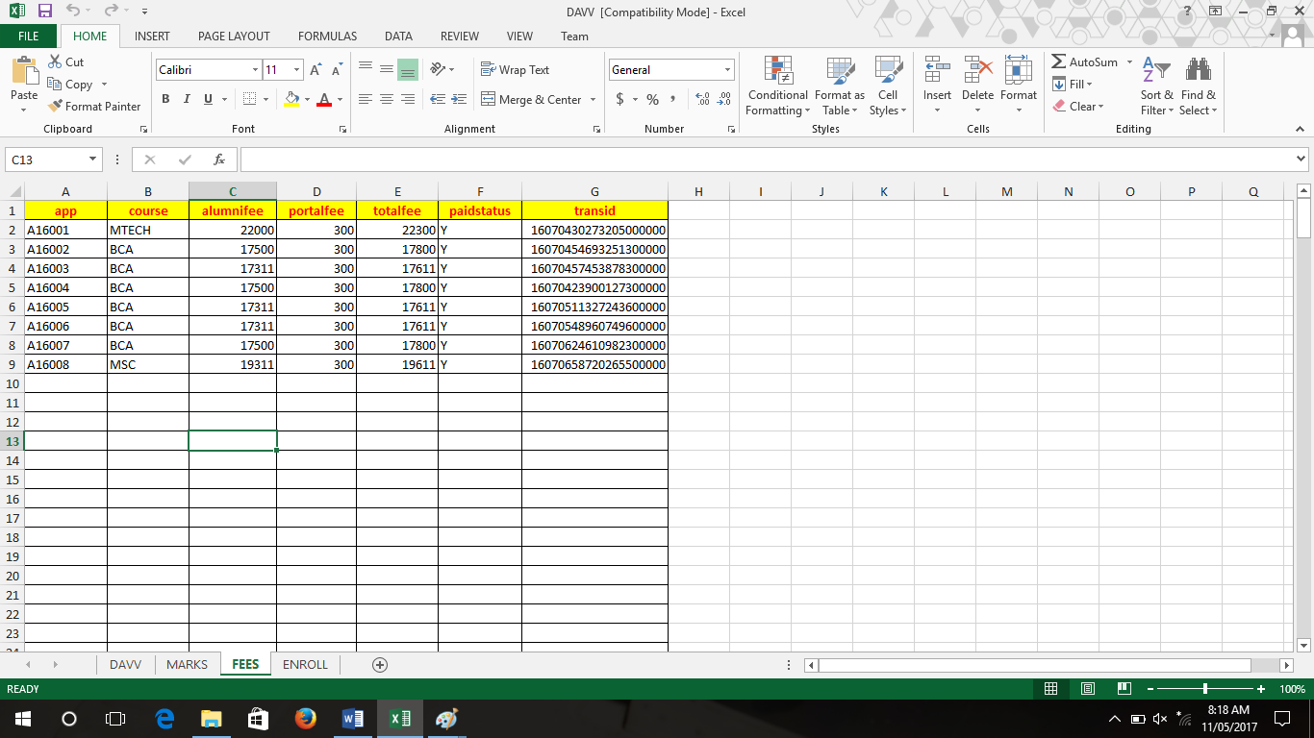**Figure-23**

Enrollment no. List

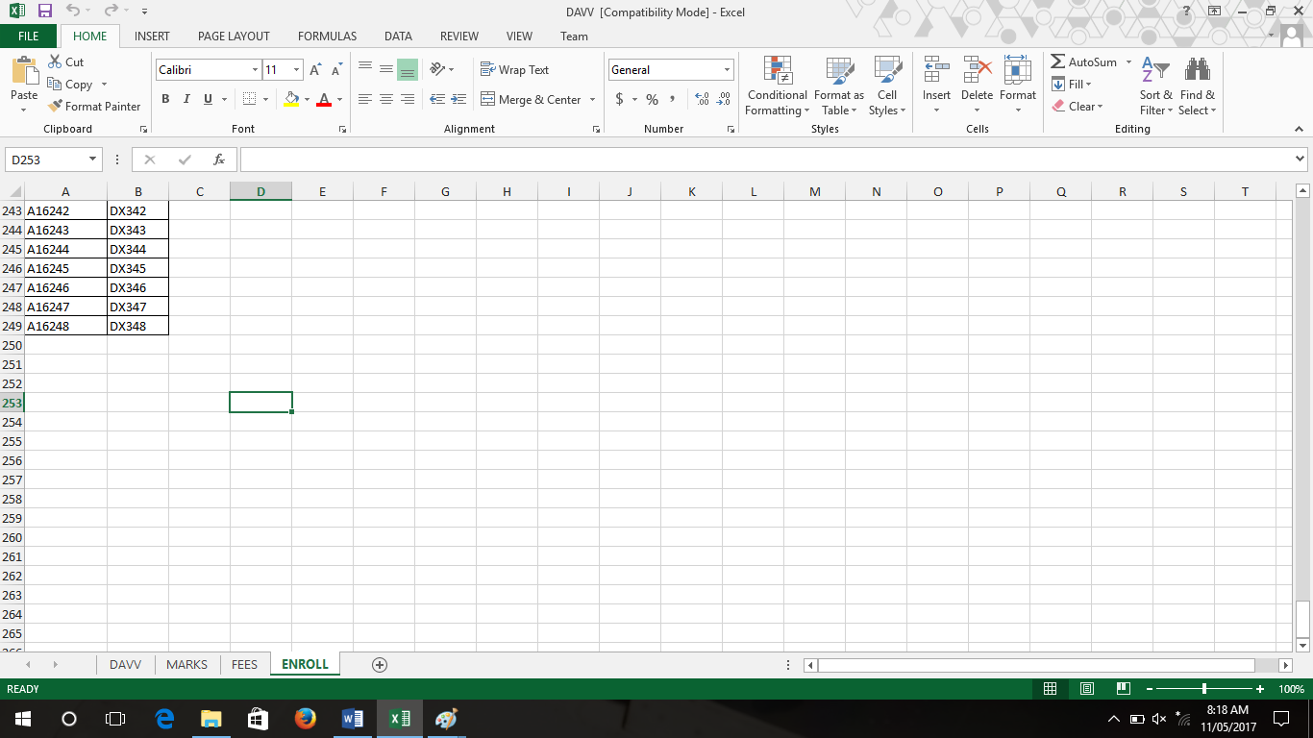

**Figure-24**

**BIBLIOGRAPHY**

**Reference Book**

1. Steven Holster (2006) ’visual basic 6 black book’ Pearson
2. System Analysis and Design: Awad, EM, Galgotia Publications Pvt. Ltd
3. Practical Standards for Microsoft® Visual Basic® .NET
4. Programming Microsoft® .NET
5. Microsoft® Visual Basic® .NET Language Reference
6. Programming Microsoft® Visual Basic® 6.0
7. www.youtube.com
8. [www.google.com](http://www.google.com)
9. [www.tutorialspoint.com](http://www.tutorialspoint.com)
10. [www.programmingknowledge.com](http://www.programmingknowledge.com)
11. www.coderspoint.com